**New York State Department of Environmental Conservation**

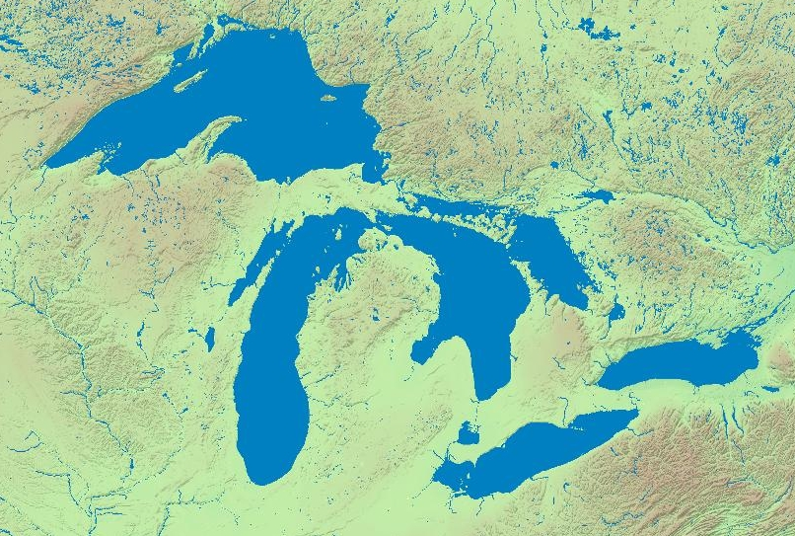

**New York Great Lakes Basin Program**

**Framework for Action 2011 – 2015**

[12-7-2010 discussion draft]

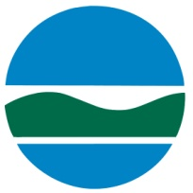

**NEW YORK’S GREAT LAKES BASIN PROGRAM**

**ACTION AGENDA 2011-2015**

**EXECUTIVE SUMMARY**

The Great Lakes region is encountering its most significant era of opportunity and challenge in many years. Investment in environmental restoration and community renewal in the Great Lakes Basin is essential for enhancing and sustaining the region’s economy and quality of life. This document proposes an agenda for action which integrates environmental, social and economic goals with new federal funding initiatives as they relate to the vital needs and benefits that people derive from the Great Lakes ecosystems. Coordinated action to implement this agenda will yield enormous benefits to the region as whole and its urban centers such as Buffalo, Rochester and Syracuse.

This Action Agenda is not a new planning exercise but a synthesis of numerous existing plans, developed over many years that have established a range of restoration and sustainable development goals for the Great Lakes region of New York State. The thirteen priority goals identified in this document are drawn from those plans. These goals are intended to establish a framework that can help us identify the strategic actions that need to be undertaken in the near-term. Making progress toward these goals will require coordinated action from federal, state and local government agencies, stakeholder organizations, scientific institutions and concerned New Yorkers.

This Agenda aims to:

* Prioritize among the many needed actions
* Promote coordination between the many entities implementing these actions
* Leverage the capacity and financial resources needed to take action.

The next step to complete this Action Agenda is to define the actions and measureable targets that should be accomplished during the period 2011- 2015 for each goal. To be effective, concrete steps need to be defined, that can be achieved within a five year time span. Engagement with the region’s stakeholders is needed to identify the most appropriate and high priority actions that should be included in this document.

Clearly, no one agency or entity has the resources to effectuate all the priorities needed to achieve desired ecosystem outcomes. This Action Agenda seeks an integrative approach to sustainably manage the resources of the Great Lakes basin by bringing together and rallying the diverse capacity and talents of the region’s stakeholders, including federal and state agencies, local government, not-for-profits, academia, business and citizens.

***FRAMEWORK FOR ACTION: PRIORITY GOALS***

***CLEAN UP POLLUTION SOURCES AND RESTORE BENEFICIAL USES***

1. **Virtually Eliminate Persistent Toxic Substances** to protect biological and human health.
2. **Control Sediment, Nutrient and Pathogen Loadings** so that people are protected from beach health hazards, drinking water quality is protected, desired aquatic biotic communities flourish, and natural processes are sustained.
3. Document and celebrate progress of restored “beneficial uses” and improved ecological health in order to accelerate **Delisting New York’s Areas of Concern**.

***CONSERVE NATURAL RESOURCES***

1. **Combat Invasive Species** to ensure that key Great Lakes species are supported for human enjoyment and to sustain a healthy ecosystem.
2. **Conserve and Restore Fish and Wildlife Biodiversity and Habitats** toachieve and sustain, to the extent possible, native biodiversity and resilient ecosystems for the benefit of future generations.
3. **Conserve Great Lakes Water Supplies** in a manner that recognizes the renewable but finite supply of the waters of the Great Lakes Basin for the use, benefit and enjoyment of the public, including generations yet to come.
4. **Restore the Lake Ontario-St. Lawrence River Shoreline** to enhance the ecological integrity of the shoreline biotic communities and to support sustainable human use and enjoyment.

***PROMOTE SUSTAINABLE DEVELOPMENT***

1. **Promote Smart Growth, Redevelopment and Adaptive Reuse** to create a sustainable and vibrant economy in the Great Lakes ecosystem.
2. **Enhance Recreation and Tourism Opportunities** that capitalize on the rivers and lakes, beauty and natural and cultural resources that defines the character of the Great Lakes region.
3. **Plan for Energy Development** consistent with natural resource conservation and supportive of the State’s energy and climate change goals.

***FOSTER LONG-TERM COORDINATED ACTION***

1. **Support Partnerships and Build Capacity** to support the collaboration and accountability necessary to achieve results.
2. **Promote Public Understanding of the Great Lakes Ecosystem,** including its important natural resources, challenges, value to the region’s communities, and the importance of stewardship.

***MAINTAIN STRONG SCIENTIFIC BASIS FOR DECISIONS***

1. **Enhance Coordinated Science, Monitoring and Information Management** to assess environmental conditions and trends, accelerate restoration progress and support natural resource management.

**INTRODUCTION**

*“THAT sentiment of the human heart which experiences pleasure in the sublime and*

*the beautiful in nature, can find on the waters of the Great Lakes and in their environment*

*a wealth of enjoyment that is offered nowhere else on the globe.”[1]*

The Great Lakes Basin is an incredible asset of state, national and international significance. The freshwater resources of the Great Lakes are invaluable to two countries. The drainages of Lakes Ontario and Erie and the St. Lawrence River are complex ecosystems that support important habitats and biological communities, provide a home to 4 million New Yorkers, and comprise a vital part of New York’s heritage and economy. Within New York, these basins total over 700 miles of shoreline and 40% of the State’s surface area – second largest among all Great Lakes states. The watersheds of these waterbodies encompass much of the geography of Upstate New York, and consist of a rich diversity of communities and natural resources. New Yorkers utilize the lakes as a source of drinking water, access their shores and waters for recreational activities, transport people and goods across the lakes, and are used for countless other activities.

Attention to the ecological health of the Great Lakes has a long history. The Boundary Waters Treaty of 1909 was the first to establish principles for international cooperation to sustainably manage shared waters. The treaty was followed by the bi-national Niagara River Water Diversion Treaty of 1950; the Convention on Great Lakes Fisheries of 1954, which created the Great Lakes Fishery Commission; and the Great Lakes Basin Compact of 1955, which created the Great Lakes Commission and yielded the Great Lakes - St. Lawrence River Ecosystem Charter in 1995.

Concerns in the early 1960s about deteriorated conditions in the lakes led to lengthy negotiations between the national governments of the United States and Canada. The ground-breaking 1972 Great Lakes Water Quality Agreement (GLWQA) established cooperative programs to address water quality impairments, particularly phosphorus and bacteria from municipal and industrial sources. The Agreement set, on a bi-national basis, basin-wide water quality objectives and included commitments to design, implement and monitor municipal and industrial pollution control programs, in conjunction with state and provincial governments. A revised Agreement, signed in 1978, added the goal of addressing pollution from persistent toxic and hazardous substances, as well as a broader goal "to restore and maintain the chemical, physical, and biological integrity of the waters of the Great Lakes Basin Ecosystem." The GLWQA and its amendments remain in effect today and guide many of our activities.

A solid body of good work and environmental improvement has taken place since the bi-national agreements were first signed. An array of governance structures, advisory bodies and scientific organizations has been established. Numerous analyses and studies have taken place, and an equivalent number of plans and strategies have been prepared to point the way to progress. Government at all levels, academia, and non-governmental organizations on both sides of the border have dedicated significant financial resources, and have successfully taken actions to improve environmental conditions in the Great Lakes.

Despite this progress, considerable work remains to be completed to fulfill the many restoration goals for the Basin. Unfortunately, as a result of piecemeal implementation activities and limited funding over many years, our collective efforts in the Basin have yet to achieve the fundamental promise of the Clean Water Act “to restore and maintain the chemical, physical and biological integrity of the Nation’s waters.” Emerging issues, such as climate change, sustainable water quantity management, invasive species and pharmaceuticals found in our waterbodies have brought attention to the need to address growing threats to human and ecosystem well-being. Adequate public funding has not been consistently available to tackle the many actions that have been identified in the various Great Lakes plans and strategies. President Obama’s Great Lakes Restoration Initiative (GRLI), enacted in 2009, brought a renewed federal commitment to restoring and protecting the Great Lakes. Sustained federal investments in GRLI on a multi-year basis will be important to effectively implement plans for Great Lakes revitalization.

To meet the challenges we still face in the Great Lakes Basin and to use our limited funding most effectively, New York’s Great Lakes Action Agenda will promote successful environmental restoration in a manner that: 1) addresses needed actions on a priority basis, 2) provides for maximum coordination and collaboration between the many implementing entities throughout the region, and 3) seeks to identify the capacity and financial resources needed to act on the identified priorities.

*“Ecosystem-based management means an integrated approach to management that considers the entire ecosystem, including humans, to achieve improved environmental conditions and sustained ecosystem services that support human needs and social goals. Ecosystem-based management differs from current approaches that usually focus on a single species, sector, activity or concern; it considers the cumulative impacts of different sectors, including human, social and economic activities.”*

from the “Scientific Consensus Statement on Marine Ecosystem-Based Management” (2005)

Climate change and ecosystem-based management are key cross-cutting State priorities integrated into this Action Agenda. Based on overwhelming scientific evidence, New York State’s air and water quality, forests, fish and wildlife habitats as well as people and communities, are at risk from climate change. Continental-scale changes in climate may result in such impacts as changing lake conditions and lake levels, decreased winter ice cover, increased lake-effect snow events, and related water-management, navigation, and hydroelectric production issues. There may be more opportunity for the introduction of invasive species with longer shipping seasons.[2] Changes in the region’s temperatures could affect fish communities, commercial and recreational fishing and the tree composition of forests. Recognizing the relationship between the Great Lakes ecosystem and climate change, the Action Agenda seeks to support the State’s dual climate change goals: to mitigate climate change, through reductions in greenhouse gas (GHG) emissions and enhancement of carbon sinks, and to adapt to the expected effects of climate change.

In an effort to promote a more integrated response to ecosystem problems, a 2006 New York State law[3] directed State agencies to employ ecosystem-based management (EBM) principles in agency programs. Within this Action Agenda the EBM principles listed in the statute have been used to guide New York’s future restoration, protection and conservation actions (e.g., placed-based focus, emphasis on protecting ecosystem structure, interconnectedness within and among systems, integration of ecological, social, economic and institutional perspectives, collaboration and adaptive management).

All State agencies, local governments, scientific institutions and other stakeholders are key partners that can help achieve the Action Agenda goals and priority actions. Through collaborative governance and ecosystem-based decision-making, we will be more effective in our planning, conservation, restoration and development activities. Integrating international, national, state and local goals and objectives will help ensure successful long-term sustainability and ecosystem health. Through a successful, coordinated effort, New York’s Great Lakes region will be stronger and more resilient for future generations.

**WATERSHEDS OF NEW YORK’S GREAT LAKES BASINS**

*“The Great Lakes are one of America’s most important—and often-overlooked—natural features….[T]he restoration of the Great Lakes would yield numerous direct, specific economic benefits: Restoring the lakes will lead to direct economic benefits of $6.5–11.8 billion dollars from tourism, fishing, and recreation alone…Restoring the Great Lakes will directly raise coastal property values $12 billion to $19 billion by remediating Areas of Concern (AOCs)…Restoring the Great Lakes will reduce costs to municipalities by $50 to $125 million dollars … All told, the direct economic benefits of restoring the Great Lakes total at least $50 billion.”*

*“Is an expenditure of this magnitude [$26 billion] worth it? With so much at stake, the restoration plan [Great Lakes Restoration Strategy] clearly seems to be a worthwhile, indeed necessary, investment.”*

John C. Austin, Soren Anderson, Paul N. Courant, Robert E. Litan, September 2007, "Healthy Waters, Strong Economy: The Benefits of Restoring the Great Lakes Ecosystem" and “America’s North Coast: A Benefit-Cost Analysis of a Program to Protect and Restore the Great Lakes", The Brookings Institution.

Place-based, integrated and scientifically-grounded management of natural resources, human activities and environmental quality are fundamental elements of EBM and this Action Agenda. Many State and Federal programs have increasingly recognized that specific ecosystem resources can be more effectively managed through planning and implementation at a watershed scale. Using a watershed approach, managers have the advantage of being able to consider common variables, geographic features, history and the many linkages and relationships between aquatic environments, their associated terrestrial watersheds and the range of human activities affecting those areas.

New York's Great Lakes region can be divided into four sub-basins to organize future implementation efforts: Lake Erie (including the Niagara River); Southwest Lake Ontario (including the Genesee River); southeast Lake Ontario (including the Seneca, Oneida, and Oswego Rivers); and Northeast Lake Ontario (including the St. Lawrence and Black Rivers).[4]

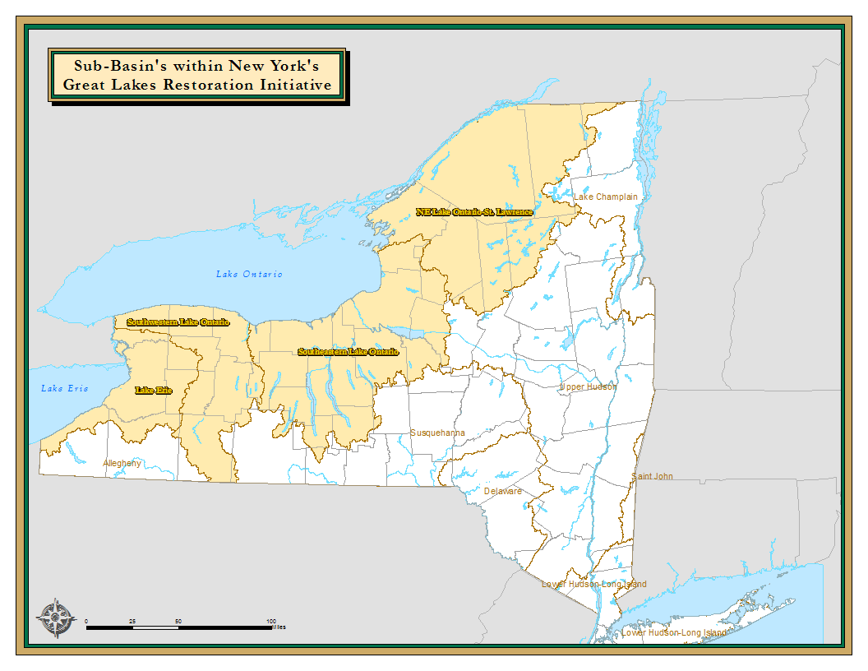

**FRAMEWORK FOR ACTION: INTEGRATING EXISTING PLANS AND STRATEGIES**

New York State recognizes its existing obligations and commitments to the many federal, interstate, regional and bi-national programs, plans and strategies developed over the past twenty years for the Great Lakes. This Agenda is not intended to create a new planning process, but rather, seeks to synthesize the goals of the range of existing plans into one common strategic agenda for action. The key goals and actions from the various existing plans have been integrated into this Action Agenda. Having a shared set of priorities will help to stimulate a more effective process for implementing the existing plans and should foster greater collaboration between involved organizations.

**BENEFICIAL USE IMPAIRMENTS**

As defined by the GLWQA, "impairment of beneficial use(s)" is a change in the chemical, physical, or biological integrity of the Great Lakes System sufficient to cause any of the following:

1. Restrictions on fish and wildlife consumption
2. Tainting of fish and wildlife flavor
3. Degradation of fish and wildlife populations
4. Fish tumors or other deformities
5. Bird or animal deformities or reproductive problems
6. Degradation of benthos
7. Restrictions on dredging activities
8. Eutrophication or undesirable algae
9. Restrictions on drinking water consumption, or taste and odor problems
10. Closing of beaches
11. Degradation of aesthetics
12. Added costs to agriculture or industry
13. Degradation of phytoplankton and zooplankton populations
14. Loss of fish and wildlife habitat

***Lakewide Management Plans (LaMPs)***

LaMPs are key mechanisms for the United States and Canada to fulfill their commitments under the Great Lakes Water Quality Agreement (GLWQA). LaMPs identify critical pollutants impairing “beneficial uses”, and identify the actions necessary to restore those beneficial uses. Through the LaMPs, analyses of the biological and physical problems facing the lakes have been undertaken, leading to the formulation of ecosystem objectives for each lake. Over time, those objectives have been refined, and the plans have evolved to define goals for each lake’s whole ecosystem, not just specific pollutants. Actions have been identified to restore beneficial uses of each lake, including those focusing on landscape and community-based actions such as Local Waterfront Revitalization Plans, Agricultural Environmental Management Plans and farm best management practices (BMPs), protection of tributary streams, prevention of non-point and point source pollution, conservation of coastal wetlands and other upland habitats, and water infrastructure improvement (traditional, as well as “green” infrastructure).

The Lake Ontario LaMP was first issued in 1998, following an extensive period of analysis, and the most recent update was in 2008. A list of ecosystem goals, objectives, impairments and initiatives are identified in the Lake Ontario LaMP and are summarized in Appendix 1.

The Lake Erie LaMP was issued in 2000, following a similar period of analysis, and was updated in 2008. A list of ecosystem goals, objectives, impairments and initiatives are identified in the Lake Erie LaMP (see Appendix 2).

***Remedial Action Plans (RAPs)***

The GLWQA also required the development of Remedial Action Plans (RAPs) for each “Area of Concern” (AOC) to address localized environmental problems, targeting the specific stressors causing the impairments and their sources. Each of New York’s six AOCs are specific geographic areas where significant pollution problems have been identified as impairing beneficial uses such as swimming, eating fish, or drinking water. New York’s AOCs are: Buffalo River, Eighteen Mile Creek, Niagara River, Rochester Embayment, Oswego River/Harbor, and St. Lawrence River at Massena. The current status of the Beneficial Use Impairments (BUI) for Lake Ontario and Lake Erie are attached as Appendix 3. The Oswego AOC is the only U.S. AOC to have been de-listed. The types of actions identified in the RAPs range from monitoring, remediation of contaminated sediment, remediation of hazardous waste sites, controls on municipal and industrial wastewater discharges, and improvements to combined sewer overflows. A priority objective within this Action Agenda is to identify the actions necessary to de-list all the AOC’s with U.S. Environmental Protection Agency (EPA) and the International Joint Commission (IJC).

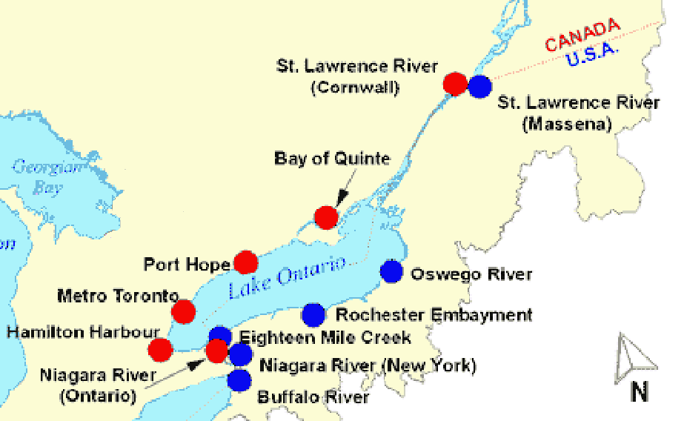

***Great Lakes Fisheries Management***

The development of strategic fish community objectives (FCOs) for each Great Lake was undertaken by the Great Lakes Fishery Commission and their bi-national Lake Committees (fisheries managers from the relevant state and provincial agencies). The FCOs are intended to provide a shared approach for the multiple fishery management agencies. They consider the current and most-complete scientific understanding of each lake’s ecosystem, the inter-relationship of species and the extant environmental stressors, and seek to be responsive to the social, economic, and cultural needs and preferences of stakeholders. For Lake Erie and Lake Ontario, the DEC holds annual “State-of-the-Lake” public meetings to convey the status, trends and developments in fish populations, angler activity, harvests and emerging stressors. These meetings are used to solicit public input on proposed changes to fish management regulation and to inform the necessary responses to emerging issues.

***25-Year Plan for the Great Lakes***

In June of 1992 New York State issued its “25-Year Plan for the Great Lakes,” which described the significance of the Great Lakes ecosystem to New York State, as well as the inherent complexities of managing such an extensive area. The 25-Year Plan was the management framework to provide for long-term vitality of the ecosystem, to guide State actions to restore ecosystem components, and to secure ecological balance while benefiting human health and welfare. New York has made tremendous progress in implementing the many components of the 25-Year Plan. Yet New York has done so with no focused Great Lakes governance system. Many of the Plan’s recommendations remain relevant today, and thus have been incorporated into this Action Agenda.

***Other Applicable Plans***

There are many other plans, strategies and policies which have direct bearing on the goals of this Action Agenda. These include:

* New York State Energy Plan (2009);
* Executive Order 24 which established a State goal to reduce the emission of greenhouse gases by 80% from 1990 levels by 2050 and required the development of a Climate Action Plan to address greenhouse gas mitigation and climate change adaptation;
* New York State Comprehensive Wildlife Conservation Strategy (2005);
* North American Waterfowl Management Plan;
* New York State Open Space Conservation Plan (2009);
* New York State Priority Waterbodies List;
* Comprehensive Outdoor Recreation Plan;
* Local Waterfront Revitalization Plans; and
* Numerous watershed, regional and municipal plans.

**NEW YORK’S GREAT LAKES ACTION AGENDA 2011-2015**

The thirteen priority goals identified in this Action Agenda are drawn from numerous existing plans, developed over many years, which have established restoration and sustainable development goals for the Great Lakes region of New York State. In the following pages, challenge statements for each goal provide the context and define the issues. The goals are intended to establish a framework that can help us identify the strategic actions that need to be undertaken in the near-term.

To be effective, we need to move beyond the aspirational goals and objectives embodied in the existing plans for the Great Lakes and define concrete actions and measurable targets that can be achieved during the period 2011-2015. Through active stakeholder engagement that is anticipated to more fully develop this Action Agenda, specific priority actions measures should be identified that can be included in the final document.

**CLEAN UP POLLUTION SOURCES AND RESTORE BENEFICIAL USES**

**Goal 1: Virtually Eliminate Persistent Toxic Substances** to protect biological and human health.

*Challenge:*

Throughout much of the 20th century, industrial development supported the economy and prosperity of the Great Lakes region. One unfortunate legacy of this industrial activity is the well-documented contamination in places such as Buffalo, Niagara Falls, Rochester and Massena. Persistent, bioaccumulative toxic substances were released into the environment, such as mercury, polychlorinated biphenyls (PCBs), Mirex, chlorinated dioxins, dieldrin, furans and toxaphene.

The 1987 GLWQA established a joint U.S. and Canadian goal that "the discharge of any and all persistent toxic substances be virtually eliminated." Both countries committed to develop control programs related to these toxics. After many years of negotiation, they signed the Great Lakes Binational Toxics Strategy (GLBTS) in 1997 that laid out the collaborative process to accomplish the “virtual elimination” goal.

Under the GLBTS, thirteen of the original seventeen challenge goals have been met for persistent toxic substances. For example, since 1987 there has been an 89% reduction of releases of dioxins and furans in the U.S. and since 1990 an estimated reduction of more than 50% of mercury releases. By 1998, the use or release of all five Level 1 pesticides [define. What are these?] in the in the U.S. portion of the Great Lakes Basin had ceased.

Nevertheless, the continued presence of toxic substances, such as mercury and PCBs, in Great Lakes fish, serves as a reminder that despite the many regulatory and remediation efforts of the past decades, there is much more work to do. Additional clean-up and prevention of exposure to past discharges remains a fundamental priority.

In Lake Ontario and its immediate watershed, critical pollutants are continuing to decline, as evidenced by a variety of indicators, but many are still present at levels above established criteria. For example, inputs of toxics from suspended sediment in the Niagara River have declined significantly from 1960 levels. Nevertheless, fish advisories are still in effect, due to the levels of PCBs, dioxins, mirex and mercury; concentrations are declining, but are above threshold levels.

The Niagara River Toxics Management Plan identified 18 priority toxics targeted for reduction and established a goal of a 50% reduction of ten specific priority toxics believed to be from significant Niagara River sources by 1996. Overall, that goal has been met, with some of these toxics seeing a more than 75% reduction through actions targeted to point and non-point sources. In order to meet the “virtual elimination” goal, continued reductions in toxic loadings of PCBs, dioxin/furans, mercury, hexachlorobenzene and benzo(a)pyrene from Niagara River sources must continue.

Clean-up and control of “legacy” pollutants is only part of the solution to protect the Great Lakes ecosystem from the impacts of toxic substances. New chemicals used in manufacturing and in domestic settings are being detected in the environment on an increasing basis, but their environmental or biological effects are uncertain. Pollutants of “emerging concern”that could significantly impact biological and human health include brominated flame retardants, fluorinated compounds, pharmaceuticals and personal care products. The costs and consequences of past chemical discharges demonstrate the importance of taking precautionary and prevention approaches to the discharge of these pollutants.

*Actions and Measurable Targets:*

* Collaborate with Great Lakes Commission and RAP coordinators to develop five year prioritized action-plan and process to achieve remediation steps necessary to achieve de-listing.
* Provide additional support to RAP coordinators to ensure necessary financial and personnel resources to accomplish prioritized de-listing action plan.
* Others to be determined.

**Goal 2: Control Sediment, Nutrient and Pathogen Loadings** so that people are protected from beach health hazards, drinking water quality is protected, desired aquatic biotic communities flourish, and natural processes are sustained.

*Challenge:*

Although water quality in the open waters of the lakes has greatly improved in recent decades, it remains an ongoing concern in the near-shore environment, where most of society’s interaction with the water occurs. Poor water quality in near-shore areas, including embayments (bays, river mouths and wetlands), reduces aquatic life, limits recreational use, and ultimately affects economic development in the region. Both Lakes suffer from microbial and chemical contamination and algal blooms. Pollutants enter the lakes via rivers, precipitation, atmospheric deposition, sewage treatment plant outfalls, combined sewer overflows, waste sites, and runoff from urban and agricultural areas.

This pollution can:

* compromise the safety, taste, and odor of drinking water;
* make beaches and near-shore areas unswimmable;
* have long-term effects on the health of humans and animals;
* impact the health and functioning of ecosystems;
* destroy or degrade habitats; and
* cause economic losses for recreational fisheries, boating, and tourism, which threaten the economic stability and quality of life for entire communities.

Near-shore algal blooms have resulted in beach closures, drinking water quality concerns, added costs to industry, and disrupted lower food webs. A top LaMP priority remains better management of nutrients, and an examination of linkages to land-based sources of nutrient loadings, particularly near-shore, so that management actions can be properly targeted. Several State University of New York (SUNY) researchers, led by SUNY Brockport, are working to assess phosphorous loadings to Lake Ontario from various types of tributaries and the transport dynamics within the nearshore zones, including hypothetical “phosphorous shunting” by zebra and quagga mussels.

Phosphorus remains a key issue in Lake Erie, primarily in the lake’s western and central basins. Great progress was made over many years to reduce phosphorus levels and loadings from anthropogenic sources, meeting the goals of the GLWQA and reducing the effects of eutrophication. But in the past decade total phosphorus levels have been on the rise. As a result, recent harmful algal blooms rival those of the 1970s. In 2005, new research and monitoring was undertaken to help forecast hypoxic conditions and harmful algal blooms, and to assess their consequences for the aquatic food web. The impact of zebra and quagga mussels on the nutrient dynamics in the near-shore areas, timing of major storms, changes in the food web, and changes in the type of phosphorus inputs to the Lake appear to be major causes of the current problems. The Lake Erie LaMP is producing a Nutrient Management Strategy that will drive commitments by all levels of government around the basin to undertake more stringent controls of non-point pollution, excessive nutrient run-off and shoreline erosion.

Many beaches still experience closings due to microbiological contamination. Combined sewer overflows, or CSOs, are important contributors to that problem. A number of Great Lakes municipalities, such as Buffalo and Syracuse, are currently implementing mitigation plans. Nevertheless, without additional action, beach water quality could become a more significant problem, due to the expected increase of severe weather events resulting from climate change. EPA recently assessed the impact climate change would have on communities in the Great Lakes region that are trying to achieve CSO mitigation bydesigning systems to permit no more than four overflow events per year. With expected effects of climate change, these communities may find it necessary to consider design modifications to ensure this standard can be met in the future.

Addressing CSOs is just one of the several documented needs for identified increased wastewater infrastructure funding; within the New York's Great Lakes drainage basin this need is estimated at $3.1 billion. Investments are needed in both “green” infrastructure and traditional engineered solutions.

To best target needed water quality improvements for the 2011-2015 period, the most recent New York State “Waterbody Inventory/Priority Waterbodies Lists,” the LaMPs, and RAPs should be used to target actions to the location and severity of impairments.

.

*Actions and Measurable Targets:* [Can we define targets or geographic priorities for these?]

* Upgrade waste water infrastructure.
* Continue investment to reduce and control urban and agriculture run-off .
* Restore nearshore and upland wetlands.
* Promote infiltration and restoration of the natural hydrologic cycle within the watershed.
* Address septic systems
* Implement Lake Ontario Coastal Initiative Action Plan (LOCI 2006)
* Other to be determined.

**Goal 3:** Document and celebrate progress of restored “beneficial uses” and improved ecological health in order to accelerate **Delisting New York’s Areas of Concern**.

*Challenge:*

While “Areas of Concern” (AOCs) were first designated more than twenty years ago, the Oswego River is the only AOC in the U.S. to have been officially de-listed. In order to achieve full de-listing of New York’s other five AOCs, (i.e., Buffalo River, Niagara River, Eighteenmile Creek, Rochester Embayment and the St. Lawrence River at Massena) many implementation projects are needed to restore the identified beneficial uses specific to each AOC.

The de-listing process requires the concurrence of the EPA and the IJC. To support a de-listing proposal, New York must complete needed implementation projects and provide monitoring data showing a beneficial use is no longer impaired. When the data shows all identified beneficial use impairments have been eliminated, then DEC can submit a proposal to the EPA and IJC for removing the AOC designation for that area in its entirety. New York has created a handbook “Guidance for (Redesignation) Delisting of Great Lakes Areas of Concern (AOCs) and their Beneficial Use Impairment (BUI) Indicators in New York State” to guide local communities and advisory committees through the documentation and review process.

Each AOC has developed [by whom?] a Stage 2 Report and is creating a supplementary Strategic Action Plan that identifies priority actions needed to restore beneficial uses. These plans will be the critical guide to direct federal funding to accomplishing local restoration projects within each AOC.

*Actions and Measurable Targets:*

* Accelerate completion of Stage 2 Strategic Action Plans for each AOC.
* Conduct data synthesis, involve experts, and address questions to resolve concerns of beneficial use restoration and protection;
* Accomplish public outreach to achieve strategic approach, consensus and beneficial results;
* Conduct monitoring to document desired end-points and outcomes are achieved;
* Apply guidance, principles, and facilitation to complete process; and
* Demonstrate follow-up and “life after delisting” through core State environmental programs and existing framework organizations.

**CONSERVE NATURAL RESOURCES**

**Goal 4: Combat Invasive Species** to ensure that key Great Lakes species are supported for human enjoyment and to sustain a healthy ecosystem.

*Challenge:*

Invasive species (IS) are non-native species that threaten the economic well-being and ecological balance of the Great Lakes Basin. Once introduced, these species can spread rapidly and potentially alter the integrity of established, natural ecosystems. Populations of invaders can grow at exponential rates and quickly dominate previously healthy systems due to a lack of control by natural predators in their new environment and the resultant ability to out-compete native species. Alteration of ecosystems in this way leads to important environmental and socio-economic concerns, and in some instances, may have implications for human health.

The aquatic ecosystems of the Great Lakes have been vulnerable to aquatic IS that have already been introduced and the threat of new introductions continues. Climate change could allow for longer shipping seasons in the Great Lakes and thus more opportunities for introducing aquatic IS. Key species impacting the resources of Lakes Ontario and Erie include alewife and rainbow smelt, zebra and quagga mussels, sea lampreys, round goby, spiny waterfleas, bloody-red shrimp, viral hemorrhagic septicemia virus, water chestnut, and Eurasian milfoil. The restoration of certain fish species and biological communities in the Great Lakes have been made more difficult as a result of IS that destroy habitat and out compete native species for food and transmit disease. In addition, municipal infrastructure facilities and recreational boating marinas can be negatively impacted.

An important priority is to prevent new aquatic IS introductions to the region, especially through ship ballast water, recreational activities, and commerce of live organisms.

With the assistance and guidance of the NY Invasive Species Council, New York has created and is implementing an Invasive Species Management Plan that lays out different approaches to IS control and eradication, depending on the desired goals or outcomes:

* Eradication - complete extirpation of a population of IS;
* Containment - management of an IS population that focuses on spread prevention, including slowing the spread;
* Management - management of an IS population that focuses on reducing the impacts of the IS.  A wide variety of treatments are available; biocontrol has the potential to be effective and efficient over the long haul;
* A combination of the above - may be appropriate for widespread species, e.g., local eradication of Phragmites to protect rare wetland habitats;
* Spread prevention - often through outreach - is necessary for all but the truly ubiquitous species.

*Actions and Measurable Targets:*

* Form an expert technical working group to consider techniques for controlling current AIS. The NYS Partnerships for Regional Invasive Species Management (PRISM) network may provide a mechanism for assembling such a group of experts.
* Through U.S. Army Corps of Engineers (USACOE), assess feasibility of a barrier to AIS movement in the Champlain Canal, and consider extending this analysis to the NYS Barge Canal.
* Additional actions to be determined.

**Goal 5: Conserve and Restore Fish and Wildlife Biodiversity and Habitats** toachieve and sustain, to the extent possible, native biodiversity and resilient ecosystems for the benefit of future generations.

*Challenge:*

While some past fish and wildlife management and conservation efforts have been single-species in focus, present and future success in the Great Lakes will depend upon protecting [managing?] assemblages of species and their habitats. This will require a continued focus on a holistic view of ecosystems and habitat protection which fully considers relationships between species and their habitat needs over the course of their lifecycles. It also requires taking a more holistic, ecosystem approach to managing land use and the cumulative impact of human activities in order to best enhance native biodiversity and habitats.

Significant amounts of near-shore and wetlands habitats have been lost or fundamentally altered in the Great Lakes due to poor land use practices and unnatural water level regulation by the IJC. Wetlands and the near-shore waters are two of the most biologically productive habitat types. Freshwater wetlands provide important food sources for many organisms, offer refuge for migratory waterfowl, and serve as breeding, spawning, and nursery grounds. In addition, wetlands and riparian buffers and their plant communities serve an important role in filtering contaminants from runoff and maintaining water quality. Near-shore habitats are critical to the reproduction of many Great Lakes fish, as eggs, fry, and juvenile life stages depend on these habitats during these most vulnerable life stages. Local land use decisions and IJC water level regulation can result in habitat fragmentation and adversely impact the connectivity within and between habitats. In addition, climate change predictions for the Great Lakes region suggest decreases in summer water levels, diminished recharge of groundwater supplies, flow reductions in small streams and decreases in wetland area, all of which could result in poorer water quality and loss of critical wildlife habitat. Land-use change and habitat fragmentation combined with climate change-induced shrinking of streams and wetlands may decrease the areas available to aquatic organisms, especially those with limited dispersal capabilities such as amphibians and mollusks.[5]

For Lake Ontario, existing plans establish key ecosystem components (or “biodiversity targets”). These targets are imperiled by five critical threats: incompatible development, invasive species, dams and barriers, non-point source pollution, and climate change. For each ecosystem component, existing plans identify threats and corresponding actions.

According to the 2005 State Comprehensive Wildlife Conservation Strategy, the greatest threat to both aquatic and terrestrial species in the Lake Erie and Lake Ontario Basins was loss of habitat from conversion to a human dominated land use. Anthropogenic changes like development (residential and commercial, roads, power lines), dredging, and wetland draining reduce habitat quantity and quality. Habitat restoration and improvements in aquatic habitat connectivity have been identified as key objectives for the restoration of Atlantic salmon, lake sturgeon, American eel and lake trout.

“Fish Community Objectives” (FCOs) have been developed for Lake Erie, Lake Ontario and the upper St. Lawrence River (draft). Developed by committees of the relevant fisheries management agencies with regular advice from the public, these resource management documents have provided a common set of goals:

“To secure fish communities, based on foundations of stable self-sustaining stocks, supplemented by judicious plantings of hatchery-reared fish, and provide from these communities an optimum contribution of fish, fishing opportunities and associated benefits to meet needs identified by society for: wholesome food, recreation, cultural heritage, employment and income, and a healthy aquatic ecosystem (Great Lakes Fishery Commission 1980, 1997).”

These documents reflect historical conditions, current threats, and altered ecology within these waters and watersheds. FCOs seek to balance competing human uses, including the desire to restore native fish populations while also maintaining a viable, productive sportfishery, which relies, in part, on stocked or naturalized non-native species. Ecosystem-based monitoring and restoration projects are needed to meet the FCOs for each lake. [Is there a connection between FCOs and habitat issues?]

Lake Erie historically supported an important commercial trout fishery. A Lake Erie Lake Trout Restoration Plan was adopted in 1985 and has been revised several times since, reflecting a considerable body of new research and the impacts of invasive mussels and sea lamprey predation. Decisions for lake trout restoration may require trade-offs that reflect broader fish community goals for the Lake. The Lake Erie Committee is also contemplating efforts to restore populations of lake herring, *Coregonus artedi*.

An important goal for Lake Ontario is restoration of naturally reproducing populations of lake trout. While natural reproduction is occurring, their abundance is well below targeted levels and the number of adult fish has declined since the early 1990s. Numbers of lake trout stocked have been reduced, and the survival of stocked fish remains low likely due to IS mediated changes to the offshore food web. A revised management plan is currently under review, which recommends increased stocking and improving strain diversity. The Lake Ontario Committee is also currently engaged in research supporting the reintroduction of native deepwater ciscoes (*Coregonus sp.*). Draft plans supporting this effort, lake sturgeon restoration and American eel recovery are currently under review.

In addition, New York’s 2005 Comprehensive Wildlife Conservation Strategy, along with the Lake Ontario LaMP’s Binational Biodiversity Conservation Strategy, should serve as the key frameworks for promoting habitat restoration, connectivity, protection and conservation of the variety of other species of concern.

*Actions and Measurable Targets:*

* Actions to protect and restore 200,000 acres of wetlands in the Great Lakes Basin, the “wetlands challenge” included in the *Great Lakes Regional Collaboration Strategy.*
* Land protection and management on public lands and strategies that deal with partnerships with private landowners, consistent with the 2009 State Open Space Conservation Plan. [define action-oriented, specific, and measureable targets that would help accomplish this goal]
* Develop a research and monitoring plan to detect, record, and analyze changes in populations, species range, habitat composition, natural cycles, and fish and wildlife health, and effectively address current and future threats in relation to changing climate conditions.
* Maintain hydrologic flows consistent with the needs of fish and wildlife and the functions of streams and rivers.
* Fund and initiate community based watershed planning which encourages development and conservation in appropriate areas.
* Pursue restoration of selected native Coregonid species, with monitoring to assess the effectiveness of juvenile stocking compared to egg releases.
* Implement restoration plans for the American eel and lake sturgeon.
* Engage sportfishing stakeholders in the restoration of native species.
* Implement specific recommended actions identified for targeted priority locations, as identified in 2009 Lake Ontario Biodiversity Conservation Strategy (e.g., Ontario Bays, Salmon River, Sandy Creeks, Black River, Oswego River, Lakeshore marshes, Irondequoit Creek, Lower Genesee River and Braddock Bay).
* Others to be determined.

**Goal 6: Conserve Great Lakes Water Supplies** in a manner that recognizes the renewable but finite supply of the waters of the Great Lakes Basin for the use, benefit and enjoyment of the public, including generations yet to come.

*Challenge:*

Although New York is a water-rich state, it must continue to strengthen its capabilities to better understand and manage its water resources in the Great Lakes region. This is especially true given the growing demand for water, including water for human consumption and energy production. As other parts of the country experience large changes in drought frequency and intensity, New York’s water resources may become a defining economic asset resulting in the migration of people and businesses into the State. This may bring some economic benefits but will also present new challenges as pressure on water resources increases.

The potential for greater pressure, and perhaps unsustainable, use of Great Lakes water resources led to international actions to ensure that effective safeguards are put into place to protect these resources on a regional basis. On December 13, 2005, the Great Lakes Governors and Premiers signed two agreements to protect the waters of the Great Lakes: 1) *Great Lakes-St. Lawrence River Basin Sustainable Water Resources Agreement* and 2) *Great Lakes-St. Lawrence River Basin Water Resources Compact*. During 2008, New York joined the other Great Lakes states and Congress in ratifying the Compact. The *Compact* provides a comprehensive management framework for achieving sustainable water use and resource protection in the Great Lakes Basin, including both its surface and groundwater resources. The *Agreement* and the *Compact* deal with water supply issues, including out-of basin diversions, the management and regulation of water withdrawals and the assessment of significant impacts due to water withdrawals and consumptive uses.

As required under the *Compact*, New York established baseline volumes for existing water withdrawals in December of 2009. The Parties to the *Compact* and *Agreement* also established “Goals and Objectives for Water Conservation and Efficient Use,” and “Water Withdrawal Information Reporting and Management Protocols” to be used across the basin. Work is currently underway to develop protocols for cumulative impact assessment of water withdrawals and consumptive uses.

New York must fulfill two near-term deliverables due under the *Agreement* and *Compact*:

* By December 2010, New York needs to adopt a water conservation and water use program consistent with Compact guidance; and,
* By December 2013, New York needs to adopt a management or regulation program to implement all other provisions of the *Compact*; this program should seek to enhance consistency in water supply management on a statewide basis. In response to this requirement, in 2009 the Governor proposed legislation (S.8280-A/A.11436-B), which would authorize DEC to implement a statewide water withdrawal permitting program, consistent with the provisions of the *Compact*.

*Actions and Measurable Targets:*

* Continue to work with the Compact Council/Regional Body [Great Lakes-St. Lawrence River Basin Water Resources Council?]
* Further assess New York State’s “water budget” to better understand the availability, limitations, and allocations of water and how that budget intersects with economic development, population growth, and ecological health.
* Implement the recommendations of GLBAC 2010 report [list specific, and measureable targets from the report]
* Develop and adopt stream flow guidelines, gauging networks and estimation tools to evaluate the hydrological impacts of climate change, individual and cumulative water withdrawals, and unsustainable land uses upon aquatic biodiversity and water supply.

**Goal 7: Restore the Lake Ontario-St. Lawrence River Shoreline** to enhance the ecological integrity of the shoreline biotic communities and to support sustainable human use and enjoyment.

*Challenge:*

The *Boundary Waters Treaty of 1909* between the United States and Canada governs the regulation of water levels and water quantity of the shared resource of Lake Ontario and the St. Lawrence River. Unfortunately, the existing lake level regulations have resulted in an overall degradation of the shoreline and wetland ecosystem of the Lake and the River. The existing regulations are based on a fifty year-old policy that did not consider the ecosystem impacts. With improved scientific information, the importance of an approach that moves toward the restoration of a more natural range of water levels and natural seasonal and long-term variation of water levels is more apparent.

Restoration of natural water level variability can have economic benefits for the region. It will improve overall environmental quality that is a cornerstone for the well-being of the residents and an important attraction for visitors. Property values, tourism, recreation and economic development all depend on maintaining high environmental quality. In addition to these direct economic impacts, the barrier sand dunes and coastal wetlands provide valuable flood storage capacity; buffer uplands from wave and storm impacts; serve as critical habitat for bird, mammal, fish, amphibian and reptile species of special concern; filter upland storm water runoff; and contribute significantly to the maintenance of the entire ecosystem.

Studies by the IJC and others demonstrate the continuing risk of damages to property along the Lake Ontario shoreline from elevated water levels and storm waves. It has been estimated that 50% of the Lake Ontario shoreline has protective structures erected in an attempt to reduce these impacts.[6] Storm damages and the direct and indirect costs of these shore defense structures will continue despite these individual efforts. Shore defense structures contribute to down drift erosion, loss of beaches, and impairment of near-shore sediment processes.

In the face of intense pressure from climate change, invasive species, water withdrawals and multiple uses, more sustainable management practices need to be implemented for these water bodies and their associated human and natural communities. New approaches to water level regulation are needed that will provide sustainable conditions now and in the future.

*Actions and Measurable Targets:*

* Support IJC adoption of a more sustainable, Plan B+ type, water level management plan.
* Target resources to Lake Ontario shoreline communities for infrastructure improvements and improved shoreline stewardship.
* Others to be determined.

**PROMOTE SUSTAINABLE DEVELOPMENT**

Rather than looking at social and economic activities as separate from the natural ecosystem, this Action Agenda integrates relevant social and economic goals, as they relate to ecosystem health and the services people derive from the Great Lakes ecosystem.

**Goal 8: Promote Smart Growth, Redevelopment and Adaptive Reuse** to create a sustainable and vibrant economy in the Great Lakes ecosystem.

*Challenge:*

Over the course of several decades, many Great Lakes urban centers have experienced a dramatic decline of the manufacturing sector, population out-migration, suburbanization, shrinking revenues and overall economic distress. Cities in the region host many under-utilized “brownfields” sites, vacant industrial buildings, and distressed or abandoned residential buildings. A focus on re-development of urban centers offers the opportunity to improve the economy and ecosystem health at the same time.

Through the Governor's Smart Growth Cabinet, New York State agencies have been exploring how to use good planning to create livable communities, protect natural resources, and promote economic growth. Through the application of smart growth principles, State and municipal government can use zoning, planning, property tax, and infrastructure spending policies[7] to encourage redevelopment and concentrate new development near transportation nodes and existing infrastructure, promote the use of public transit, and avoid sprawl. Smart growth approaches have clear environmental benefits: improved air and water quality, reduction of greenhouse gas emissions, greater habitat and open space protection, farmland preservation, clean-up and re-use of brownfield sites, elimination of blight, and fish and wildlife protection.

By strategically focusing State financial support and land use development to existing urban areas, the Great Lakes region can accomplish its economic development goals, leverage the value of existing infrastructure, reduce development pressure in greenfields, and support the State’s climate change mitigation goals. Also, smart growth development patterns can have the benefit of reducing the costs of providing public infrastructure and delivering services thereby enhancing the region’s economic competiveness.

*Actions and Measurable Targets:*

* Identify options to enable and expand the use of public transit
* Implement mixed-use, smart-growth, land-use and planning policies that result in reductions of vehicle-miles-traveled within the region.
* Others to be determined.

**Goal 9: Enhance Recreation and Tourism Opportunities** that capitalize on the rivers and lakes, beauty and natural and cultural resources that define the character of the Great Lakes region.

*Challenge:*

New York’s Great Lakes region offers outstanding tourism and recreation opportunities: world-class freshwater fishing and boating; eco-tourism and agri-tourism experiences such as birding and winery tours; and hiking trails, heritage tourism, and beautiful state parks. Lakefront communities are increasingly seen as attractive places, with municipalities emphasizing waterfront revitalization as a key economic development strategy.

Water resources provide the backdrop for many of the wonderful tourism offerings of the Great Lakes Basin. Water is important to the recreational offerings of the area. Water is important to the recreational offerings of the area. The location of major urban centers such as Buffalo, Rochester, Oswego and Niagara Falls fronting on the major lakes and rivers provides opportunities to capitalize on the growing interest in accessing waterfront areas for commercial and recreational uses.

The enjoyment of the Great Lakes ecosystem provides substantial economic benefits to the region. Based on the 2007 New York Statewide Angler Survey, the New York Great Lakes sport fishery was valued at $170 million annually. In total, over 4 million angler days were spent fishing on our Great Lakes waters, representing about 22% of all freshwater fishing in New York. Recreational boating in the region, similarly, provides substantial positive economic impact. Expenditures related to recreational boating in New York areas bordering the Great Lakes and Finger Lakes amounted to $600 million in 2003.[8]

The broader Great Lakes watersheds have varied landscapes that are the underlying assets that generate significant recreational and tourism activity. The Tug Hill Plateau is famous for its natural beauty, skiing, and snowmobiling. Tourism and recreation are important economic drivers for both the Finger Lakes and St. Lawrence-Thousand Island regions.

Additional boating access and shore fishing opportunities are needed throughout the Great Lakes system. No thorough analysis has been conducted to evaluate the need or the opportunities for improving waterfront access. DEC is currently utilizing funding from the Natural Resources Damages settlement with Occidental Chemical Corp. to create new and improve existing boating and shore fishing access sites along Lake Ontario and the St. Lawrence River6.

[Identify other tourism and recreational opportunities and issues, including enhancement of public swimming access (?), New York State Seaway Trail system opportunities, encouragement of winter recreation (snowmobiling??)

Increasing public appreciation and stewardship of the natural resources of the Great Lakes region should be part of any efforts to enhance recreation and tourism in the region.

*Actions and Measurable Targets:*

* Promote development of local waterfront revitalization plans as well as updating and promotion of adherence to existing waterfront plans
* Build on existing State plans and programming that promote tourism in the region
* Increase public access to Great Lakes waterfronts
* Need for dredging at harbors?
* Others to be determined.

**Goal 10: Plan for Energy Development** consistent with natural resource conservation and supportive of the State’s energy and climate change goals

*Challenge:*

The generation and transmission of energy is important to the Great Lakes region, supporting the local economy, creating jobs, and providing energy for New York and the Northeast region. There are currently over 200 operating land-based wind generators taking advantage of Lake Erie and Lake Ontario winds; several nuclear power plants that use lake water for cooling; important hydropower dams on the Niagara and St. Lawrence Rivers; and a biofuel plant in Oswego.

As the energy market continues to evolve, and demand for renewable energy increases, New York will need to find ways to balance increasing energy demand with other priorities. Many proposals are being considered for additional generation and transmission facilities in the Great Lakes region, including offshore wind energy production.

There are two core challenges for the region relating to the energy sector. The first is to determine how existing energy facilities can reduce their impacts to human health, air quality, water use, fisheries, and wildlife, while maintaining their regional and local benefits. The second challenge is to develop new energy-generating facilities that incorporate EBM principles, consider potential climate-change impacts and build resilience for meeting peak demand. Climate impacts such as higher seasonal average temperatures and increased frequency of extreme heat events will likely result in increased energy use and/or increased reliance on demand response mechanisms, energy storage and other energy resources to meet peak demands. New York’s existing and future energy projects must provide energy for the region, provide jobs, and local tax revenue. At the same time, it is essential that energy production facilities minimize impacts to fish migrations, aquatic habitat, and the productive agricultural and forested landscape, provide corridors for wildlife mobility and recreational use, minimize impacts to wildlife from transmission lines and wind turbines, minimize disturbance to stream flows and fish migration to/from impoundments, minimize impacts from water cooling operations, minimize emissions of greenhouse gases and be resilient to climate change effects. Applying EBM principles, it is imperative to assess the cumulative impacts of existing and future energy projects in New York and Ontario.

Government’s challenge is to ensure that the energy needs of New York are met, with an emphasis on clean and renewable technologies that reduce greenhouse gas emissions, while ensuring ecosystem integrity and public health. Future energy development activities in the Great Lakes region must take into account the other ecosystem goals enumerated in this Agenda. Energy planners need to accelerate the introduction of zero- or low-carbon sources of power such as renewable energy and potentially nuclear energy, while maintaining the reliability of the electric grid.

There has been increasing interest in the potential to use the Great Lakes for renewal energy development. Underwater lands near shore are under the jurisdiction of the Office of General Services (OGS), and the State has the authority to grant leases for the use of underwater lands targeted for offshore wind development. To best guide potential future developments and to address possible user conflicts and resource protection, New York State should undertake a marine spatial planning process for its portion of the Lakes. This planning should take a proactive approach to protecting ecological health, appropriate siting of energy facilities and transmission lines, and acknowledgement of the many existing uses of the lakes. Comprehensive analyses should address: impacts on habitats and biota, visual aesthetics, commercial and recreational fishing, recreational boating, shipping and transportation, and submerged cultural resources. The cumulative impacts of offshore wind development in New York and Ontario waters must be addressed.

*Actions and Measurable Targets:*

* Implement marine spatial planning for offshore areas within the Lakes that integrates energy generation, habitat protection and other uses.
* In combination with Statewide policy initiatives, make investments within the region which could improve and maintain the performance of the grid (e.g., transmission and distribution network upgrading, energy storage).
* Incorporate best available projections of changes in seasonal average temperatures and increased frequency of extreme heat events in near- and long-term demand forecasting for electricity and natural gas
* Plan to meet regional demand growth and improved system resiliency by expanding local implementation of demand response and energy efficiency measures, localized distributed generation, energy storage, other energy-supply technologies, and smart-grid technologies.
* Others to be determined.

**FOSTER LONG-TERM COORDINATED ACTION**

**Goal 11: Support Partnerships and Build Capacity** to support the collaboration and accountability necessary to achieve results.

*Challenge:*

There are a great number of organizations that have been working for many years to restore and protect the Great Lakes ecosystem — federal, state, and local agencies, numerous non-profit organizations, diverse educational institutions, and private entities. As mentioned earlier, there are a great many published Great Lakes plans, agreements, and strategies. Our challenge is to get these diverse groups to work collaboratively toward well-known, common goals and to build the capacity for action on priority implementation measures. This Action Agenda is one important step toward that efficient collaboration.

The importance of effective governance cannot be overstated. Partnerships can avoid duplicative efforts and address the need for efficient and effective use of resources, especially in a tight fiscal climate. The variety of partners can each bring their own knowledge and skills, and the integration of actions by numerous partners can bring better solutions and well-grounded decisions. Frameworks should be encouraged and supported for communication and collaboration between agency and external organizations to advance this Action Agenda and to make more aggressive progress.

In addition, the lack of adequate staffing and technical capacity at all levels has been an impediment to making more progress on the needed implementation measures identified for the region.

*Actions and Measurable Targets:*

* form a Lake Erie Watershed Alliance
* [Propose how to organize to achieve better partnerships and integration and to show progress during the period 2011-2015]
* Others to be determined.

**Goal 12: Promote Public Understanding of the Great Lakes Ecosystem,** including its important natural resources, challenges, value to the region’s communities, and the importance of stewardship.

*Challenge:*

The wealth of scientific information and plans for the Great Lakes may be compelling, but their value will fall short if they are not accessible, widely known, and put to good use. Moving forward on a collaborative action agenda requires a shared understanding of the region’s issues and broad public support for the identified actions.

The multitude of existing plans for the Great Lakes region, amount of data and breadth of identified actions over such a large geographic region is staggering for many. To make progress in a manner that maintains the strategic vision, stakeholders need readily accessible information about the state of each lake and its ecosystem, including existing conditions, stressors and their trends, progress over time, and emerging issues. To the degree it is available, access to such information at a more localized scale, can also be useful to assist management agencies and local organizations as they consider choices for restoration and implementation that are consistent with a shared vision.

Public communication of such information is important to build support for needed actions and to encourage future stewardship by residents and user groups. Thus, environmental education and communication is a key component of this overall Action Agenda.

*Actions and Measurable Targets:*

* Synthesize and publicize existing information on conditions in Lake Erie and Lake Ontario ecosystems.
* Create web‐based applications and public events that bring diverse partners and stakeholders together to update progress, share best practices, celebrate exemplar cases, provide trainings, and build linkages.
* Others to be determined.

**MAINTAIN STRONG SCIENTIFIC BASIS FOR DECISIONS**

**Goal 13: Enhance Coordinated Science, Monitoring and Information Management** to document environmental conditions and progress and to support decision-making on natural resource management and implementation measures.

*Challenge:*

The Great Lakes region has seen substantial improvements in environmental quality since the 1970s. The results have derived from the enactment of federal and state laws, bi-national programs deriving from the GLWQA, and investment by all levels of government.

Maintaining and improving the base of scientific information about the Great Lakes ecosystem is essential, in order to document success and support future actions. Research and monitoring programs, including the Great Lakes Observing System, are critical to provide information on climate change, the status of wildlife and habitats, invasive species and water quality and to increase management effectiveness. Better knowledge of the interconnections between all components of the ecosystem is important to making accurate predictions of change and to evaluate risks.

Management approaches to fisheries and other Great Lakes resources require enhanced data collection and monitoring and a determination of restoration and management goals. Important objectives should be directed to: an improved understanding of biodiversity and relationship between species; protection of sensitive habitats; understanding and minimizing impacts of invasive species and other stressors; and effect of management actions.

The Great Lakes Research Consortium may present opportunities to foster collaborative research activities with management agencies and numerous, existing collaborative efforts including LaMPs, RAPs, GLFC, etc.

*Actions and Measurable Targets:*

* Convene an annual Great Lakes scientific conference or summit within New York State to recognize exemplary EBM programs and to share research findings related to the Great Lakes ecosystem.[9]
* Through the assistance of the Great Lakes Research Consortium and Great Lakes Basin Advisory Council, develop a prioritized and targeted set of research needs that will be pursued in the short term that reflect current management priorities and develop a strategy for funding those priorities.
* Undertake an ecosystem modeling analysis of the effects of climate change, in order to predict the potential impacts of flooding, erosion, and altered precipitation quantities that may occur and their affects on communities and infrastructure, habitats, fish and wildlife.
* Others to be determined.

**REFERENCES FOR MORE INFORMATION**

[New York State 25-Year Plan for the Great Lakes](http://nysl.nysed.gov/Archimages/72072.PDF) (June 1992)

[Great Lakes Restoration Initiative Action Plan, FY2010-2014](http://greatlakesrestoration.us/action/wp-content/uploads/glri_actionplan.pdf) (February 2010)

[Great Lakes Regional Collaboration Strategy](http://www.glrc.us/strategy.html) (December 2005)

[Great Lakes Binational Toxics Strategy](http://www.epa.gov/greatlakes/bns/documents.html): Canada - United States Strategy for the Virtual Elimination of Persistent Toxic Substances in the Great Lakes (April 7, 1997; December 2008 status report)

[Joint Strategic Plan for Management of Great Lakes Fisheries](http://www.glfc.org/fishmgmt/jsp97.htm) (1981; revised 1997)

[Fish-Community Goals and Objectives for Lake Erie](http://www.glfc.org/lakecom/lec/LEC_docs/other_docs/Sp03_2.pdf) (2003)

[Lake Erie Environmental Objectives](http://www.glfc.org/lakecom/lec/EOs_July5.pdf) (2005)

[A Strategic Plan for the Rehabilitation of Lake Trout in Lake Erie, 2008-2020](http://www.glfc.org/pubs/SpecialPubs/2008-02.pdf) (December 2008)

Fish-Community Objectives for Lake Ontario ([1999](http://www.glfc.org/pubs/SpecialPubs/Sp99_1.pdf); [2003 Update](http://www.glfc.org/pubs/SpecialPubs/foc2003update.pdf))

[Fish-Community Objectives for the St. Lawrence River](http://www.dec.ny.gov/docs/wildlife_pdf/stlawrivfshobjectives.pdf) (December 14, 2001 draft)

“[The Beautiful Lake: A Biodiversity Conservation Strategy for Lake Ontario](http://www.epa.gov/glnpo/lakeont/reports/lo_biodiversity.pdf)” (April 2009; update July 2009)

[Great Lakes-St. Lawrence River Basin Water Resources Compact](http://www.cglg.org/projects/water/CompactImplementation.asp)

[Lake Erie Lake Management Plan](http://www.epa.gov/glnpo/erie.html) (LaMP) (2000; 2008 Update)

Lake Ontario Lake Management Plan (LaMP) ([1998](http://www.epa.gov/greatlakes/lakeont/lo_lamp.html); [2008 Update](http://www.epa.gov/greatlakes/lamp/lo_2008/index.html))

[Niagara River Toxics Management Plan](http://www.epa.gov/glnpo/lakeont/nrtmp/index.html) (November 1998; 2009 Annual Status Report)

[Buffalo River Remedial Action Plan](http://www.epa.gov/grtlakes/aoc/buffalo.html) (RAP) (1989; 2005 Status Report)

[Eighteenmile Creek Remedial Action Plan](http://www.epa.gov/grtlakes/aoc/eighteenmile.html) (RAP) (1997; 2001 Update)

[Niagara River Remedial Action Plan](http://www.epa.gov/grtlakes/aoc/niagara.html) (RAP) (2000)

[Rochester Embayment Remedial Action Plan](http://www.epa.gov/grtlakes/aoc/rochester.html) (RAP) (Stage 1 1993; Stage 2 1997)

[St. Lawrence River at Massena Remedial Action Plan](http://www.epa.gov/grtlakes/aoc/stlawrence.html) (RAP) (Stage 1 1990; Stage 2 1991; 2006 Status Report)

[International St. Lawrence River Board of Control Water Level/Flow Control Plan](http://www.ijc.org/conseil_board/islrbc/en/regulation.htm)

[International Niagara River Board of Control Water Level/Flow Control Plan](http://www.ijc.org/conseil_board/niagara/en/niagara_home_accueil.htm)

[Lake Erie Millennium Plan](http://web2.uwindsor.ca/lemn/)

[Our Great Lakes Water Resources: Conserving and Protecting Our Water Today for Use Tomorrow](http://www.dec.ny.gov/docs/regions_pdf/glbacrpt1.pdf) (July 2009)

[Our Waters, Our Communities, Our Future: Taking Bold Action Now to Achieve Long-term Sustainability of New York’s Ocean and Great Lakes](http://www.nyoglecc.org/media/Final_New_York_Ocean_and_Great_Lakes_Report_April_2009.pdf) (April 2009)

New York State [Comprehensive Wildlife Conservation Strategy](http://www.dec.ny.gov/animals/9404.html) (September 2005)

[North American Waterfowl Management Plan](http://www.fws.gov/birdhabitat/nawmp/Planstrategy.shtm) (1986; 1998 update; 2004 Implementation Framework)

[New York State Open Space Conservation Plan](http://www.dec.ny.gov/lands/317.html) (2009)

[State Of the Lakes Ecosystem Conference](http://binational.net/solec/intro_e.html) (SOLEC) reports (1993, 1995, 1997, 1999, 2001, 2003, 2005, 2007, 2009)

[IJC Biennial Reports on Great Lakes Water Quality](http://www.ijc.org/en/publications/rpts_bi.htm)

**Appendix 1: Ecosystem-based Management Vision, Goals and Objectives of Lake Ontario Lakewide Management Plan (LaMP)[10]**

**Ecosystem Goals**:

* The Lake Ontario ecosystem should be maintained and, as necessary, restored or enhanced to support self-reproducing and diverse biological communities;
* The presence of contaminants shall not limit uses of fish, wildlife and waters of the Lake Ontario basin by humans, and shall not cause adverse health effects in plants and animals;
* We, as a society, shall recognize our capacity to cause great changes in the ecosystem and we shall conduct our activities with responsible stewardship for the Lake Ontario basin.

**Ecosystem Objectives**:

1. Aquatic Communities - The waters of Lake Ontario shall support diverse and healthy, reproducing and self-sustaining communities in dynamic equilibrium, with an emphasis on native species. Also, support Lake Ontario Committee’s Fish Community Objectives.
2. Wildlife - The perpetuation of a healthy, diverse and self-sustaining wildlife community that uses the lake habitat and/or food shall be ensured by attaining and sustaining the waters, coastal wetlands, and upland habitats of the Lake Ontario basin in sufficient quantity and quality.
3. Human Health - The waters, plants and animals of Lake Ontario shall be free from contaminants and organisms resulting from human activities at levels that affect human health or aesthetic factors, such as tainting, odor and turbidity.
4. Habitat - Lake Ontario offshore and nearshore zones, surrounding tributary, wetland and upland habitats shall be of sufficient quality and quantity to support ecosystem objectives for the health, productivity and distribution of plants and animals in and adjacent to Lake Ontario.
5. Stewardship - Human activities and decisions shall embrace environmental ethics and a commitment to responsible stewardship.

**Ecosystem Indicators**:

1. Critical Pollutant Concentrations in (a) offshore waters, (b) young-of-year fish, (c) herring gull eggs, (d) lake trout, and (e) as compared to existing agency guidelines.
2. Lower Foodweb Status & Trends in (a) nutrients, (b) zooplankton and phytoplankton, and (c) prey fish.
3. Upper Foodweb Status & Trends in the health of (a) herring gulls, (b) lake trout, (c) bald eagles, and (d) mink and otter populations.
4. Coastal Wetlands (a) periodicity of low level events, (b) percent meadow marsh cover, and (c) changes in total wetlands surface area.

**Appendix 2: Ecosystem-based Management Vision, Goals and Objectives of Lake Erie Lakewide Management Plan (LaMP)*[11]***

**Vision** – is a Lake Erie basin ecosystem where …

* All people, recognizing the fundamental links among the health of the ecosystem, their individual actions, and the economic and physical well-being, work to minimize the human impact in the Lake Erie basin and beyond;
* Natural resources are protected from known, preventable threats;
* Native biodiversity and the health and function of natural communities are protected and restored to the greatest extent feasible;
* Natural resources are managed to ensure that the integrity of existing communities is maintained or improved;
* Human-modified landscapes provide functions that approximate natural ecosystem processes;
* Land and water are managed so water flow regimes and associated amount of materials transported mimic natural cycles; and
* Environmental health continually improves due to virtual elimination of toxic contaminants and remedial actions at formerly degraded and/or contaminated sites.

**Ecosystem Management Objectives**:

1. Land Use

Strategic Objective (SO) – Land-based activities enhance native biodiversity and ecosystem integrity.

Tactical Objective (TO) – Land use activities result in gains in the quantity and quality of natural habitat in order to support the maximum amount of native biodiversity and community integrity that can be achieved and be sustained for the benefit of future generations.

1. Nutrients

SO – Nutrient levels are consistent with ecosystem goals (watershed and basin-wide).

TO – Nutrient inputs from both point and non-point sources are managed to ensure that ambient concentrations are within bounds of sustainable watershed management and consistent with the Lake Erie vision.

1. Natural Resource Use and Disturbance

SO – Ecologically wise and sustainable use of natural resources.

TO – Natural resource use (e.g. commercial and sport fishing, hunting, trapping, logging, water withdrawal, mining, etc.) and disturbances by human presence or activity be managed to ensure that the integrity of existing healthy ecological communities be maintained and/or improved, and provide long-term benefits to consumers, and to support the Lake Erie Committee’s Fish Community Objectives.

1. Chemical & Biological Contaminants

SO – Virtual elimination of toxic chemicals and biological contaminants.

TO – Toxic chemicals and biological contaminant concentrations within the basin must be continually reduced.

1. Non-Native Species

SO – Prevent further invasions of non-native species. Control existing invasive non-native species where possible.

TO – Non-native invasive species should be prevented from colonizing the Lake Erie ecosystem. Existing non-native invasive species should be controlled and reduced where feasible and consistent with other objectives.

1. Areas of Concern (AOC)

SO – Delist all designated Areas of Concern within the Lake Erie basin.

TO – Restore the Beneficial Use Impairments (BUI) designated within each AOC’s Remedial Action Plan (RAP) to meet their respective target objectives.

**Appendix 3**

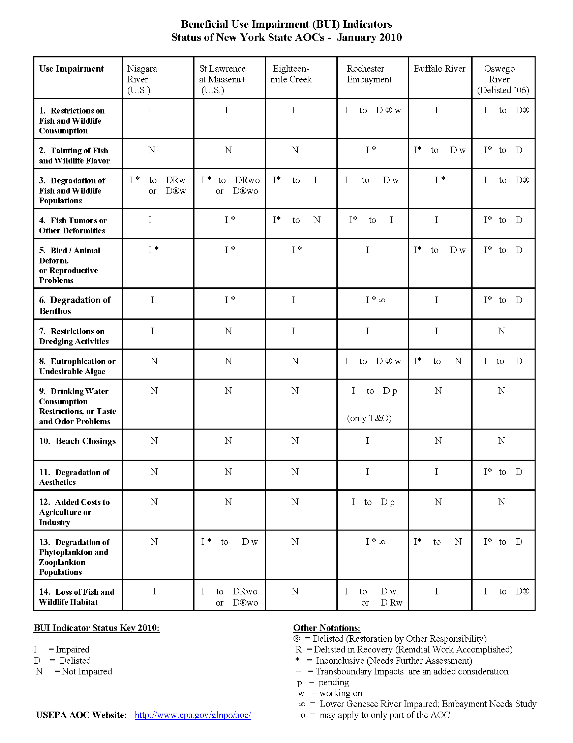

1. **History of the Great Lakes, .J. B. Mansfield, ed., Volume I, 1899, p 10.**
2. NYSERDA ClimAID Team. 2010. Synthesis Report, Integrated Assessment for Effective Climate Change Adaptation Strategies in New York State. C. Rosenzweig, W. Solecki, A.DeGaetano, S. Hassol, P. Grabhorn, M. O’Grady, eds. NYSERDA, Albany, NY.
3. “New York Ocean and Great lakes Ecosystem Conservation Act”, Article 14, New York State Environmental Conservation Law.
4. Geographic descriptions can be found at: <http://www.dec.ny.gov/animals/30483.html>.
5. Union of Concerned Scientists and Ecological Society of America. 2005. Confronting Climate Change in the Great Lakes Region: Impacts on our Communities and Ecosystems.
6. International Lake Ontario–St. Lawrence River Study Board. 2006. *Options for* *Managing Lake Ontario and St. Lawrence River Water Levels and Flows: Final Report*. Prepared for the International Joint Commission, Annex 2, p. 59.
7. In August of 2010 the "State Smart Growth Public Infrastructure Policy Act" was enacted (Chapter 433), which provides for the establishment of state smart growth criteria for public investment directed toward existing infrastructure located in traditional main streets, downtown areas and established developed areas.
8. “Great Lakes Recreational Boating’s Economic Punch” Great Lakes Commission, July 2007.

   “Recreational Boating Expenditures in 2003 in New York State and Their Economic Impacts”

   6 “Final sportfishing restoration and spending plan for the Lake Ontario System”, NYSDEC publication, October 2007.
9. Build on existing annual State of the Lakes Conferences (DEC and GLFC), annual International Association of Great Lakes Research conference, State of the Lakes Ecosystem Conference, etc.
10. <http://epa.gov/greatlakes/ontario.html>
11. <http://epa.gov/greatlakes/erie/html>